Chapter 4 Fission and fusion

Chapter test Total marks 46

Name: Class: Date: ___________

Use the following values in your calculations:

charge on an electron: *Q* = –1.60 × 10–19 C

speed of light: *c* = 3.0 × 108 m s–1

Question 1

For two nuclei to undergo fusion, which of the following must be overcome? (1 mark)

A strong nuclear force

B electrostatic force

C binding force

D weak nuclear force

Question 2

Which of the following is responsible for holding the nucleus of an atom together? (1 mark)

A strong nuclear force

B weak nuclear force

C binding force

D electrostatic force

E gravity

Question 3

For the following radioisotopes, calculate the number of:

**i** protons; **ii** neutrons; **iii** nucleons.

a  (3 marks)

b  (3 marks)

Question 4

a Balance the following equation by finding values for *A* and *Z*.

 (2 marks)

b How does the combined mass of the products compare with the mass of the uranium-238 nucleus? (1 mark)

Question 5

Consider the following fission reaction:



a Determine the identity of the unknown, *X*. (2 marks)

b Convert the energy released into joules. (1 mark)

c How much mass was converted to energy in the reaction? (2 marks)

d Using the fact that 1.00 kg of uranium-235 contains 2.5 × 1024 nuclei, how much energy would be released if all the nuclei in 1.00 kg of uranium-235 underwent fission? (2 marks)

Question 6

The layout of a thermal nuclear power station is shown in the diagram below.

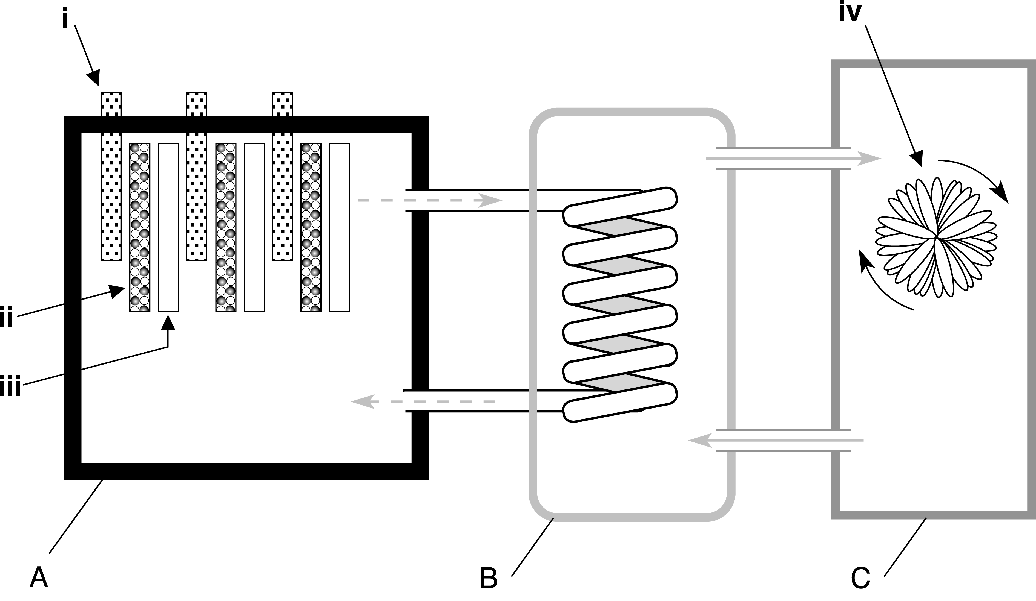

a Name the parts labelled i, ii, iii and iv. (4 marks)

b Name and describe the function of the sections labelled A, B and C. (6 marks)

Question 7

Explain why a chain reaction does not occur in a lump of uranium ore that is dug up from a uranium mine. (2 marks)

Question 8

What are the main environmental concerns associated with coal-fired power stations and nuclear power stations? (2 marks)

Question 9

A particular nuclear reactor generates about 1200 MW of electrical power, but operates at about 25% efficiency (i.e. only 25% of its thermal energy is transformed into electrical energy).

a How much electrical energy is generated each day? (2 marks)

b Assuming that this energy has been transformed from uranium-235, how much uranium-235   
(in grams) is consumed each day by this plant? (2 marks)

c How much energy is converted into electrical energy? (1 mark)

Question 10

One of the reactions that takes place in a fusion reactor is shown below:



a How many neutrons are released during this reaction (i.e. what is the value of )? (1 mark)

b How does the combined mass of the reactants compare with the combined mass of the products in this fusion reaction? (2 marks)

**c** What happens to this difference in mass? (1 mark)

d About 15 MeV of energy is released during this fusion reaction. How much energy is this in joules?

(2 marks)

Question 11

One of the fusion reactions taking place inside the Sun is shown below:



a Identify the missing nuclide, *X*. (2 marks)

b About 4.0 × 10–12 J of energy is released during this fusion reaction. How much energy is this in electron volts? (1 mark)